VISVESVARAYA TECHNOLOGICAL UNIVERSITY
“JnanaSangama”, Belgaum -590014, Karnataka.

LAB REPORT
on
Artificial Intelligence (23CS5PCAIN)
Submitted by
Anshuman Gupta (1BM23CS043)
in partial fulfillment for the award of the degree of
BACHELOR OF ENGINEERING
in
COMPUTER SCIENCE AND ENGINEERING

B.M.S. COLLEGE OF ENGINEERING
(Autonomous Institution under VTU)
BENGALURU-560019
Aug 2025 to Dec 2025

B.M.S. College of Engineering,
Bull Temple Road, Bangalore 560019
(Affiliated To Visvesvaraya Technological University, Belgaum)
Department of Computer Science and Engineering

CERTIFICATE
This is to certify that the Lab work entitled “Artificial Intelligence (23CS5PCAIN)” carried out by Ansuman Gupta(1BM23CS043), who is bonafide student of B.M.S. College of Engineering. It is in partial fulfillment for the award of Bachelor of Engineering in Computer Science and Engineering of the Visvesvaraya Technological University, Belgaum. The Lab report has been approved as it satisfies the academic requirements in respect of an Artificial Intelligence (23CS5PCAIN) work prescribed for the said degree.

Dr. K.R. Mamatha  Assistant Professor  Department of CSE, BMSCE | Dr. Kavitha Sooda  Professor & HOD  Department of CSE, BMSCE

Index
Sl.  No. | Date | Experiment Title | Page No.
1 | 18-08-2025 | Implement Tic –Tac –Toe Game  Implement vacuum cleaner agent | 4-9
2 | 25-08-2025 | Implement 8 puzzle problems using Depth First Search (DFS)  Implement Iterative deepening search algorithm | 10-19
3 | 25-08-2025 | Implement A* search algorithm | 20-25
4 | 15-09-2025 | Implement Hill Climbing search algorithm to solve N-Queens problem | 26-29
5 | 15-09-2025 | Simulated Annealing to Solve 8-Queens problem | 30-32
6 | 22-09-2025 | Create a knowledge base using propositional logic and show that the given query entails the knowledge base or not. | 33-37
7 | 13-10-2025 | Implement unification in first order logic | 38-43
8 | 13-10-2025 | Create a knowledge base consisting of first order logic statements and prove the given query using forward reasoning. | 44-47
9 | 27-10-2025 | Create a knowledge base consisting of first order logic statements and prove the given query using Resolution | 48-51
10 | 16-11-2025 | Implement Alpha-Beta Pruning. | 52-55

Github Link: https://github.com/Anshuman262005/AI_LAB



Program 1
Implement Tic –Tac –Toe Game
Implement vacuum cleaner agent
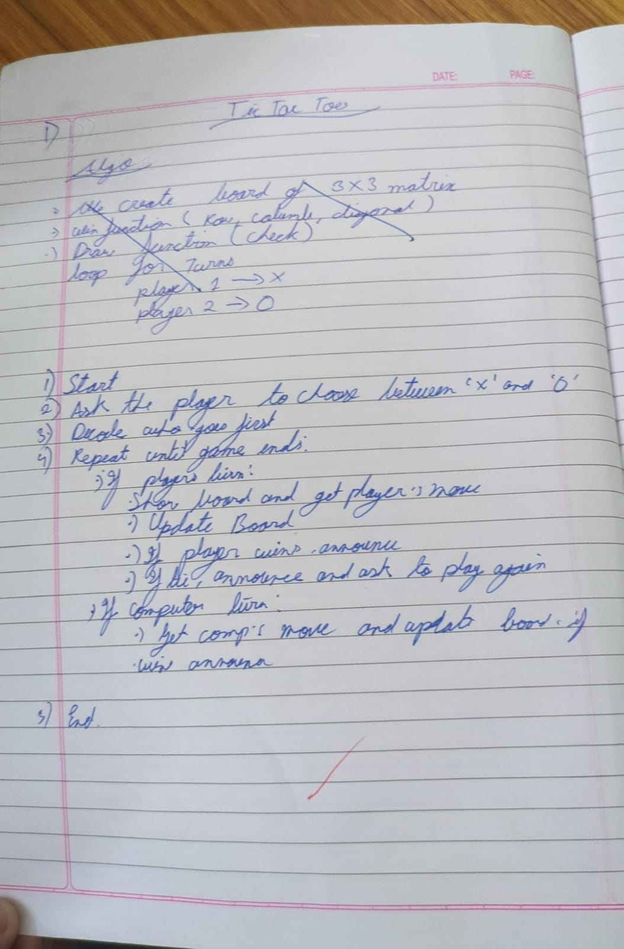
Algorithm: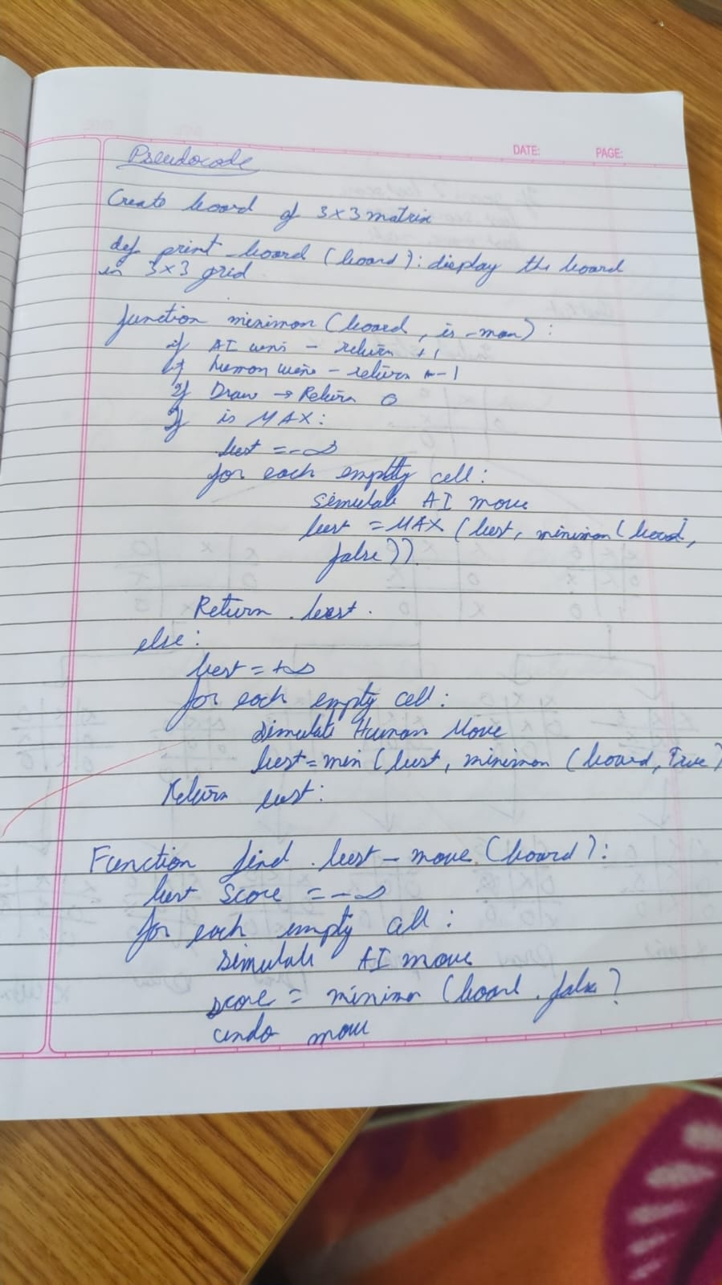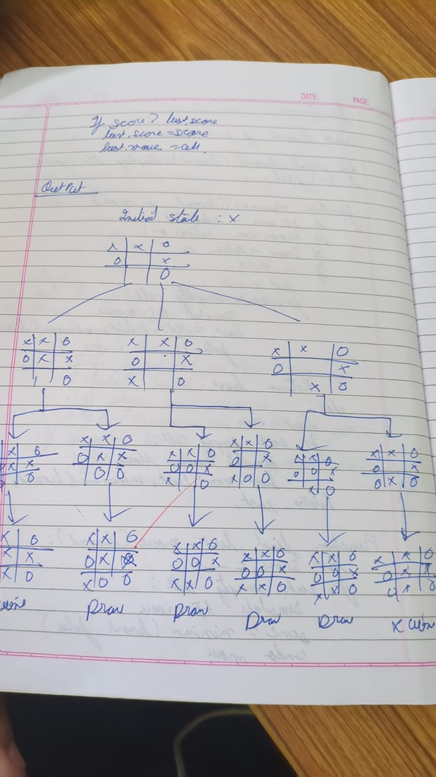
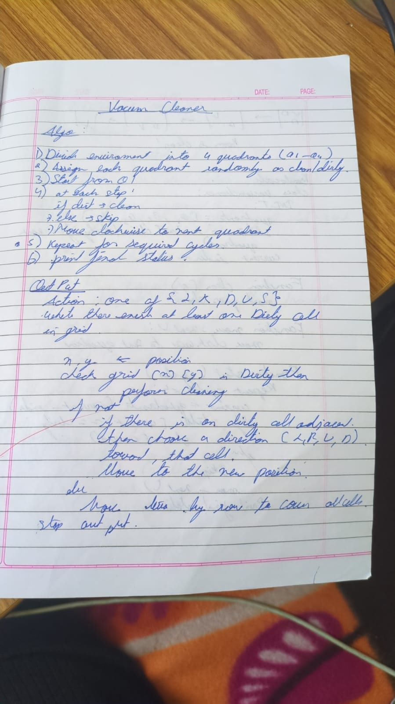
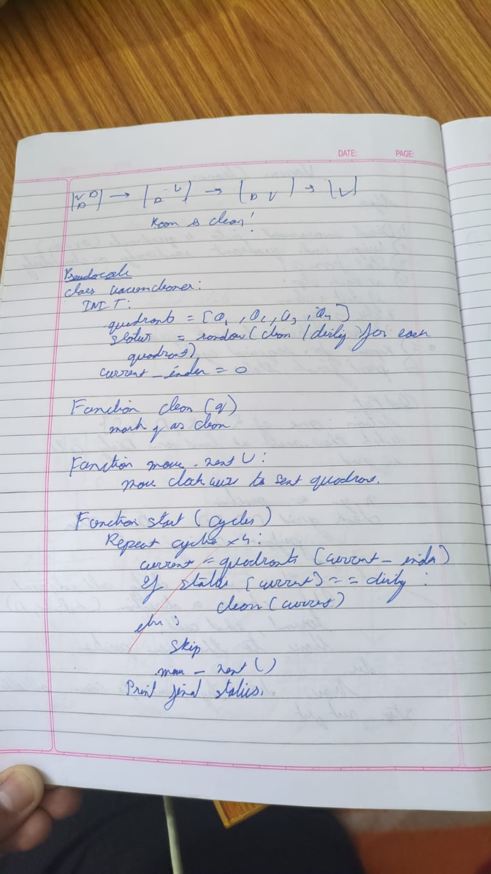
Code:
Tic tac toe:
def print_board(board):
for row in board:
print(" ".join(row))
print()

def check_winner(board, player):
for i in range(3):
if all(board[i][j] == player for j in range(3)):
return True
if all(board[j][i] == player for j in range(3)):
return True
if all(board[i][i] == player for i in range(3)):
return True
if all(board[i][2 - i] == player for i in range(3)):
return True
return False

def is_draw(board):
return all(board[i][j] != '-' for i in range(3) for j in range(3))

def minimax(board, is_ai_turn):
if check_winner(board, 'O'):
return 1
if check_winner(board, 'X'):
return -1
if is_draw(board):
return 0

if is_ai_turn:
best_score = -float('inf')
for i in range(3):
for j in range(3):
if board[i][j] == '-':
board[i][j] = 'O'
score = minimax(board, False)
board[i][j] = '-'
best_score = max(score, best_score)
return best_score
else:
best_score = float('inf')
for i in range(3):
for j in range(3):
if board[i][j] == '-':
board[i][j] = 'X'
score = minimax(board, True)
board[i][j] = '-'
best_score = min(score, best_score)
return best_score

def manual_game():
board = [['-' for _ in range(3)] for _ in range(3)]
print("Initial Board:")
print_board(board)

while True:
while True:
try:
x_row = int(input("Enter X row (1-3): ")) - 1
x_col = int(input("Enter X col (1-3): ")) - 1
if board[x_row][x_col] == '-':
board[x_row][x_col] = 'X'
break
else:
print("Cell occupied!")
except:
print("Invalid input!")

print("Board after X move:")
print_board(board)

if check_winner(board, 'X'):
print("X wins!")
break
if is_draw(board):
print("Draw!")
break

while True:
try:
o_row = int(input("Enter O row (1-3): ")) - 1
o_col = int(input("Enter O col (1-3): ")) - 1
if board[o_row][o_col] == '-':
board[o_row][o_col] = 'O'
break
else:
print("Cell occupied!")
except:
print("Invalid input!")

print("Board after O move:")
print_board(board)

if check_winner(board, 'O'):
print("O wins!")
break
if is_draw(board):
print("Draw!")
break

cost = minimax(board, True)
print(f"AI evaluation cost from this position: {cost}")

manual_game()
print("Name: Sanchit Mehta and USN : 1BM23CS299")

vaccum cleaner:
rooms = int(input("Enter Number of rooms: "))
Rooms = "ABCDEFGHIJKLMNOPQRSTUVWXYZ"
cost = 0
Roomval = {}

for i in range(rooms):
print(f"Enter Room {Rooms[i]} state (0 for clean, 1 for dirty): ")
n = int(input())
Roomval[Rooms[i]] = n

loc = input(f"Enter Location of vacuum ({Rooms[:rooms]}): ").upper()

while 1 in Roomval.values():
if Roomval[loc] == 1:
print(f"Room {loc} is dirty. Cleaning...")
Roomval[loc] = 0
cost += 1
else:
print(f"Room {loc} is already clean.")

move = input("Enter L or R to move left or right (or Q to quit): ").upper()

if move == "L":
if loc != Rooms[0]:
loc = Rooms[Rooms.index(loc) - 1]
else:
print("No room to move left.")
elif move == "R":
if loc != Rooms[rooms - 1]:
loc = Rooms[Rooms.index(loc) + 1]
else:
print("No room to move right.")
elif move == "Q":
break
else:
print("Invalid input. Please enter L, R, or Q.")

print("\nAll Rooms Cleaned." if 1 not in Roomval.values() else "Exited before cleaning all rooms.")
print(f"Total cost: {cost}")

Program 2

Implement 8 puzzle problems using Depth First Search (DFS):
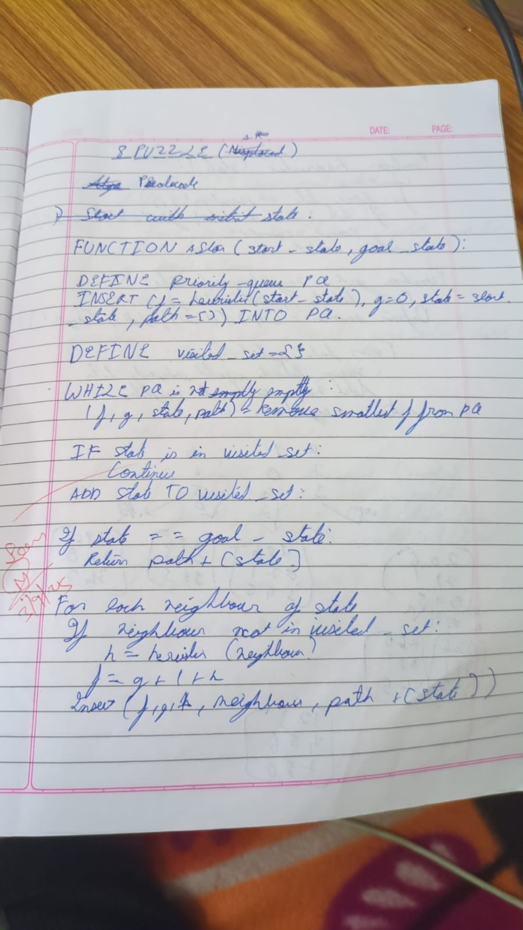

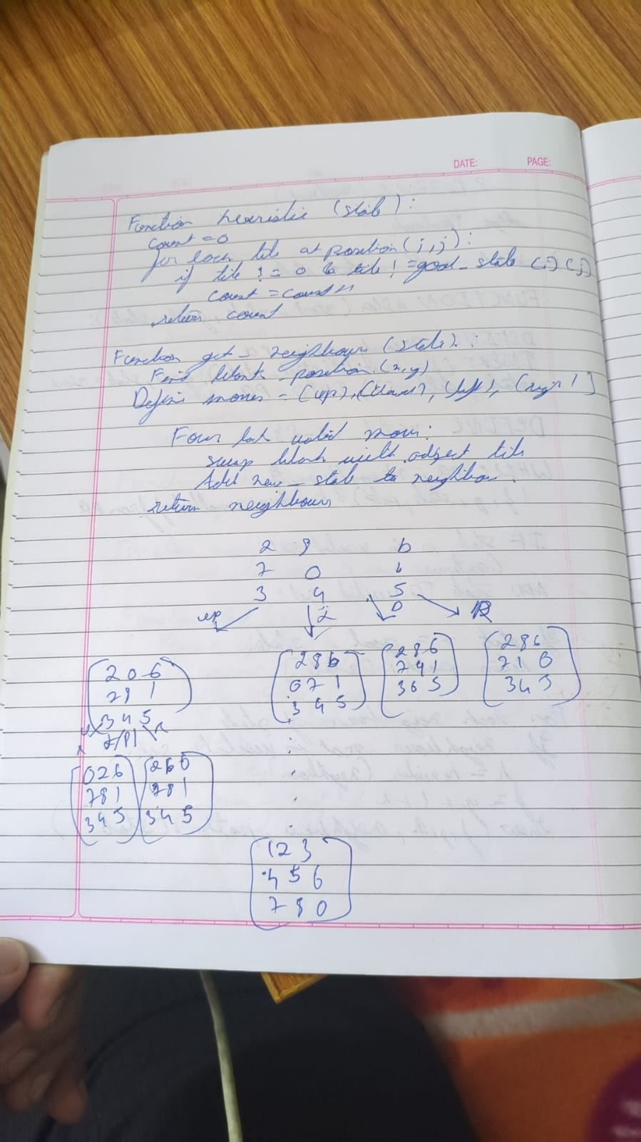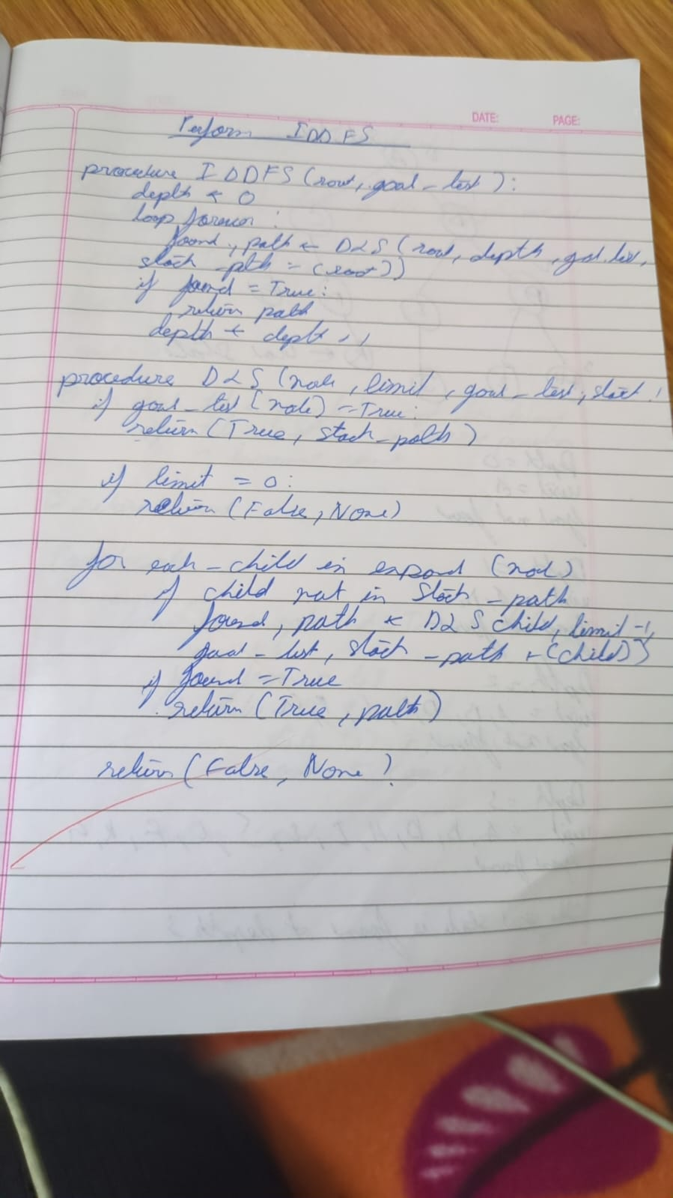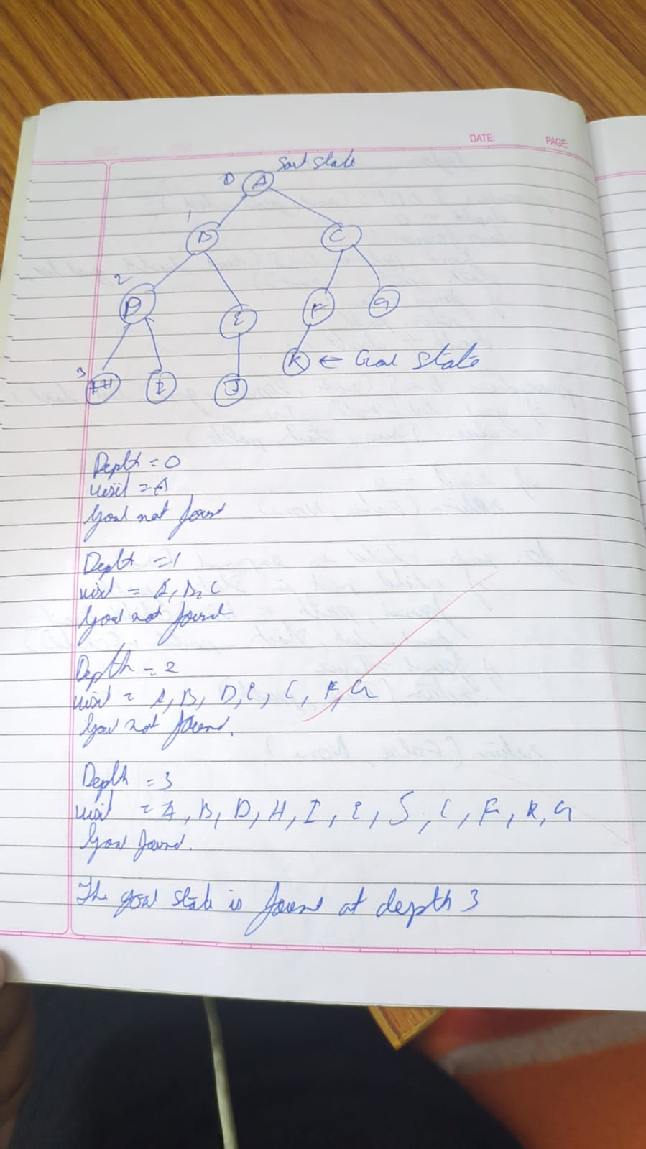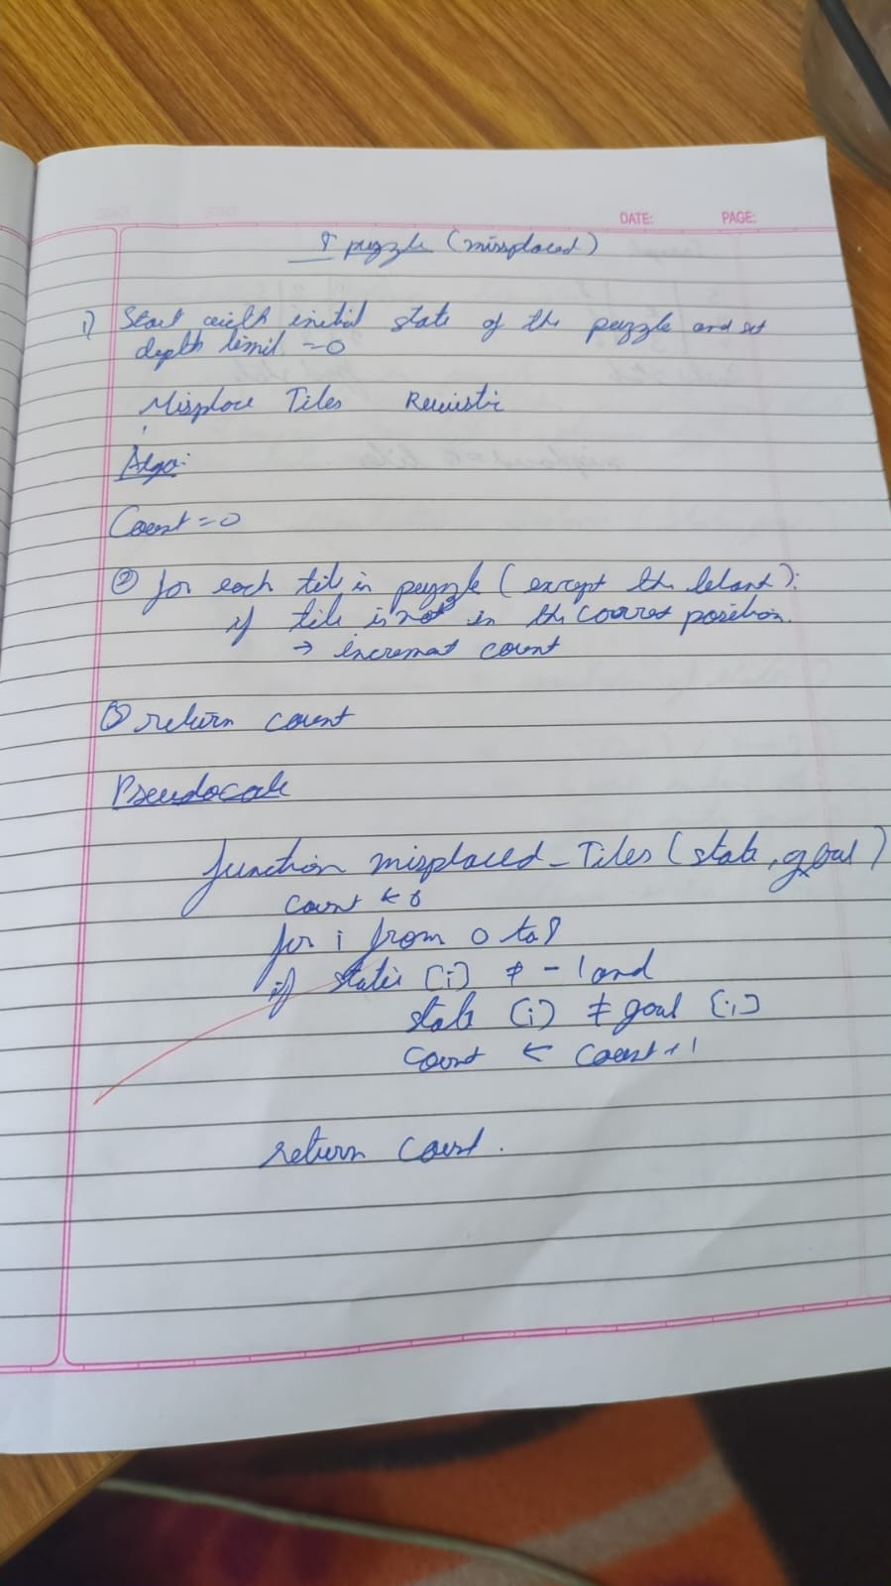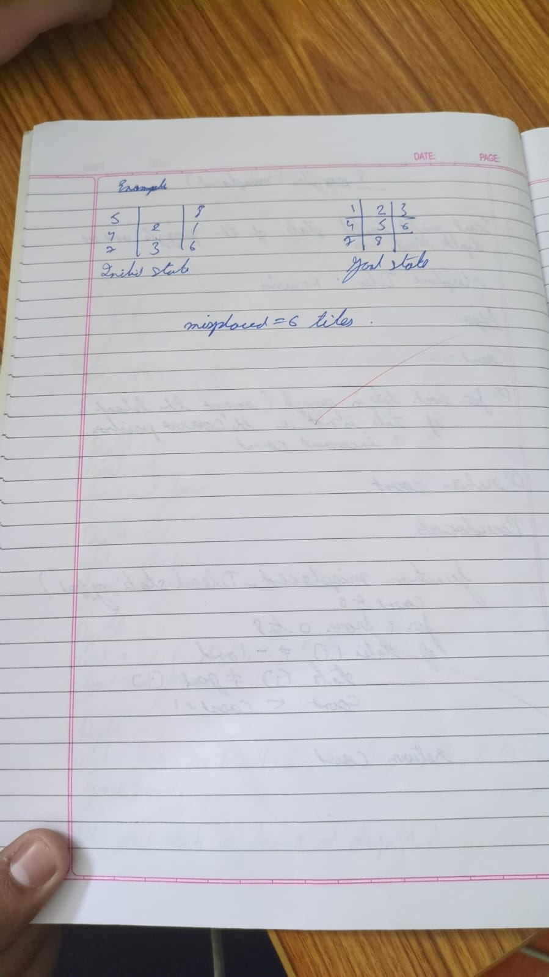

goal_state = '123804765'

moves = {
'U': -3,
'D': 3,
'L': -1,
'R': 1
}
count = 0
invalid_moves = {
0: ['U', 'L'], 1: ['U'], 2: ['U', 'R'],
3: ['L'], 5: ['R'],
6: ['D', 'L'], 7: ['D'], 8: ['D', 'R']
}

def move_tile(state, direction):
index = state.index('0')
if direction in invalid_moves.get(index, []):
return None

new_index = index + moves[direction]
if new_index < 0 or new_index >= 9:
return None

state_list = list(state)
state_list[index], state_list[new_index] = state_list[new_index], state_list[index]
return ''.join(state_list)

def print_state(state):
for i in range(0, 9, 3):
print(' '.join(state[i:i+3]).replace('0', ' '))
print()

def dfs(start_state, max_depth=50):
visited = set()
stack = [(start_state, [])] # Each element: (state, path)

while stack:
current_state, path = stack.pop()

if current_state in visited:
continue

# Print every visited state
print("Visited state:")
print_state(current_state)

if current_state == goal_state:
return path

visited.add(current_state)
global count
count +=1
if len(path) >= max_depth:
continue

for direction in moves:
new_state = move_tile(current_state, direction)
if new_state and new_state not in visited:
stack.append((new_state, path + [direction]))

return None

start = input("Enter start state (e.g., 724506831): ")

if len(start) == 9 and set(start) == set('012345678'):
print("Start state:")
print_state(start)

result = dfs(start)

if result is not None:
print("Solution found!")
print("Moves:", ' '.join(result))
print("Number of moves:", len(result))
print("Number of visited states",count)

current_state = start
for i, move in enumerate(result, 1):
current_state = move_tile(current_state, move)
print(f"Move {i}: {move}")
print_state(current_state)
else:
print("No solution exists for the given start state or max depth reached.")
else:
print("Invalid input! Please enter a 9-digit string using digits 0-8 without repetition.")

Implement Iterative deepening search algorithm:
goal_state = '123456780'

moves = {
'U': -3,
'D': 3,
'L': -1,
'R': 1
}

invalid_moves = {
0: ['U', 'L'], 1: ['U'], 2: ['U', 'R'],
3: ['L'], 5: ['R'],
6: ['D', 'L'], 7: ['D'], 8: ['D', 'R']
}

def move_tile(state, direction):
index = state.index('0')
if direction in invalid_moves.get(index, []):
return None

new_index = index + moves[direction]
if new_index < 0 or new_index >= 9:
return None

state_list = list(state)
state_list[index], state_list[new_index] = state_list[new_index], state_list[index]
return ''.join(state_list)

def print_state(state):
for i in range(0, 9, 3):
print(' '.join(state[i:i+3]).replace('0', ' '))
print()

def dls(state, depth, path, visited, visited_count):
visited_count[0] += 1 # Increment visited states count
if state == goal_state:
return path

if depth == 0:
return None

visited.add(state)

for direction in moves:
new_state = move_tile(state, direction)
if new_state and new_state not in visited:
result = dls(new_state, depth - 1, path + [direction], visited, visited_count)
if result is not None:
return result

visited.remove(state)
return None

def iddfs(start_state, max_depth=50):
visited_count = [0] # Using list to pass by reference
for depth in range(max_depth + 1):
visited = set()
result = dls(start_state, depth, [], visited, visited_count)
if result is not None:
return result, visited_count[0]
return None, visited_count[0]

# Main
start = input("Enter start state (e.g., 724506831): ")

if len(start) == 9 and set(start) == set('012345678'):
print("Start state:")
print_state(start)

result, visited_states = iddfs(start,15)

print(f"Total states visited: {visited_states}")

if result is not None:
print("Solution found!")
print("Moves:", ' '.join(result))
print("Number of moves:", len(result))

current_state = start
for i, move in enumerate(result, 1):
current_state = move_tile(current_state, move)
print(f"Move {i}: {move}")
print_state(current_state)
else:
print("No solution exists for the given start state or max depth reached.")
else:
print("Invalid input! Please enter a 9-digit string using digits 0-8 without repetition.")

Program 3

Implement A* search algorithm
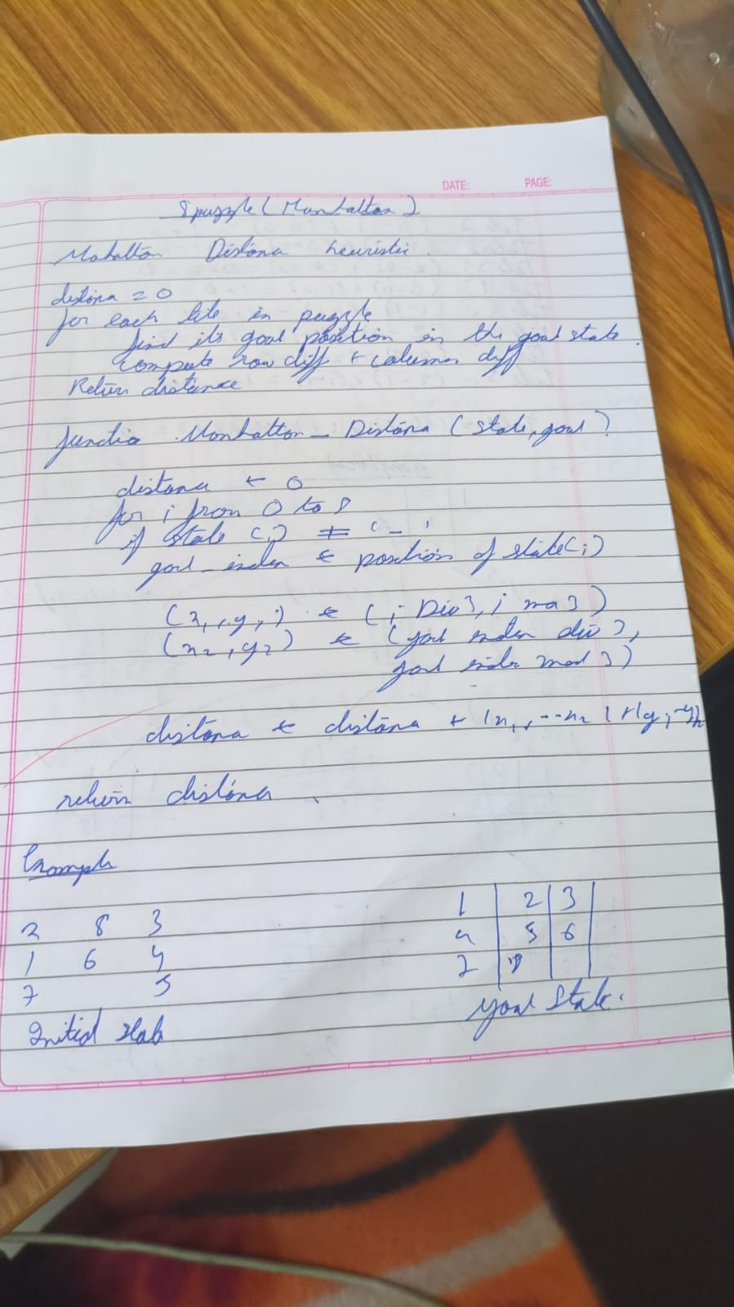
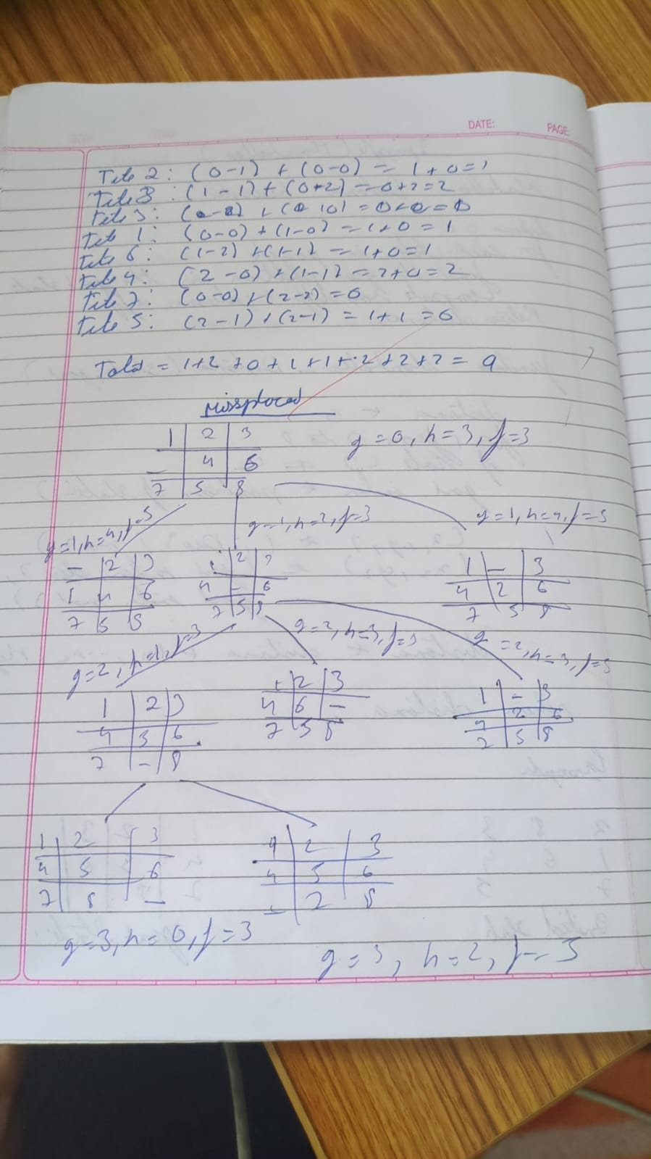
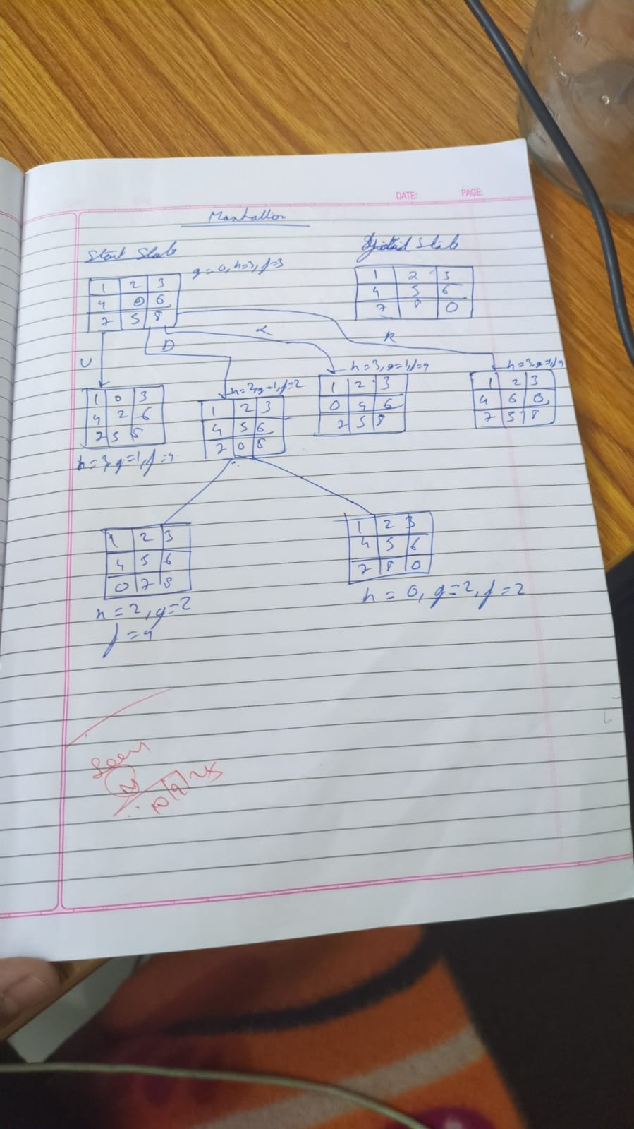

import heapq

goal_state = '123456780'

moves = {
'U': -3,
'D': 3,
'L': -1,
'R': 1
}

invalid_moves = {
0: ['U', 'L'], 1: ['U'], 2: ['U', 'R'],
3: ['L'], 5: ['R'],
6: ['D', 'L'], 7: ['D'], 8: ['D', 'R']
}

def move_tile(state, direction):
index = state.index('0')
if direction in invalid_moves.get(index, []):
return None

new_index = index + moves[direction]
if new_index < 0 or new_index >= 9:
return None

state_list = list(state)
state_list[index], state_list[new_index] = state_list[new_index], state_list[index]
return ''.join(state_list)

def print_state(state):
for i in range(0, 9, 3):
print(' '.join(state[i:i+3]).replace('0', ' '))
print()

def manhattan_distance(state):
distance = 0
for i, val in enumerate(state):
if val == '0':
continue
goal_pos = int(val) - 1
current_row, current_col = divmod(i, 3)
goal_row, goal_col = divmod(goal_pos, 3)
distance += abs(current_row - goal_row) + abs(current_col - goal_col)
return distance

def a_star(start_state):
visited_count = 0
open_set = []
heapq.heappush(open_set, (manhattan_distance(start_state), 0, start_state, []))
visited = set()

while open_set:
f, g, current_state, path = heapq.heappop(open_set)
visited_count += 1

if current_state == goal_state:
return path, visited_count

if current_state in visited:
continue
visited.add(current_state)

for direction in moves:
new_state = move_tile(current_state, direction)
if new_state and new_state not in visited:
new_g = g + 1
new_f = new_g + manhattan_distance(new_state)
heapq.heappush(open_set, (new_f, new_g, new_state, path + [direction]))

return None, visited_count

# Main
start = input("Enter start state (e.g., 724506831): ")

if len(start) == 9 and set(start) == set('012345678'):
print("Start state:")
print_state(start)

result, visited_states = a_star(start)

print(f"Total states visited: {visited_states}")

if result is not None:
print("Solution found!")
print("Moves:", ' '.join(result))
print("Number of moves:", len(result))

current_state = start
for i, move in enumerate(result, 1):
current_state = move_tile(current_state, move)
print(f"Move {i}: {move}")
print_state(current_state)
else:
print("No solution exists for the given start state.")
else:
print("Invalid input! Please enter a 9-digit string using digits 0-8 without repetition.")

Program 4
Implement Hill Climbing search algorithm to solve N-Queens problem

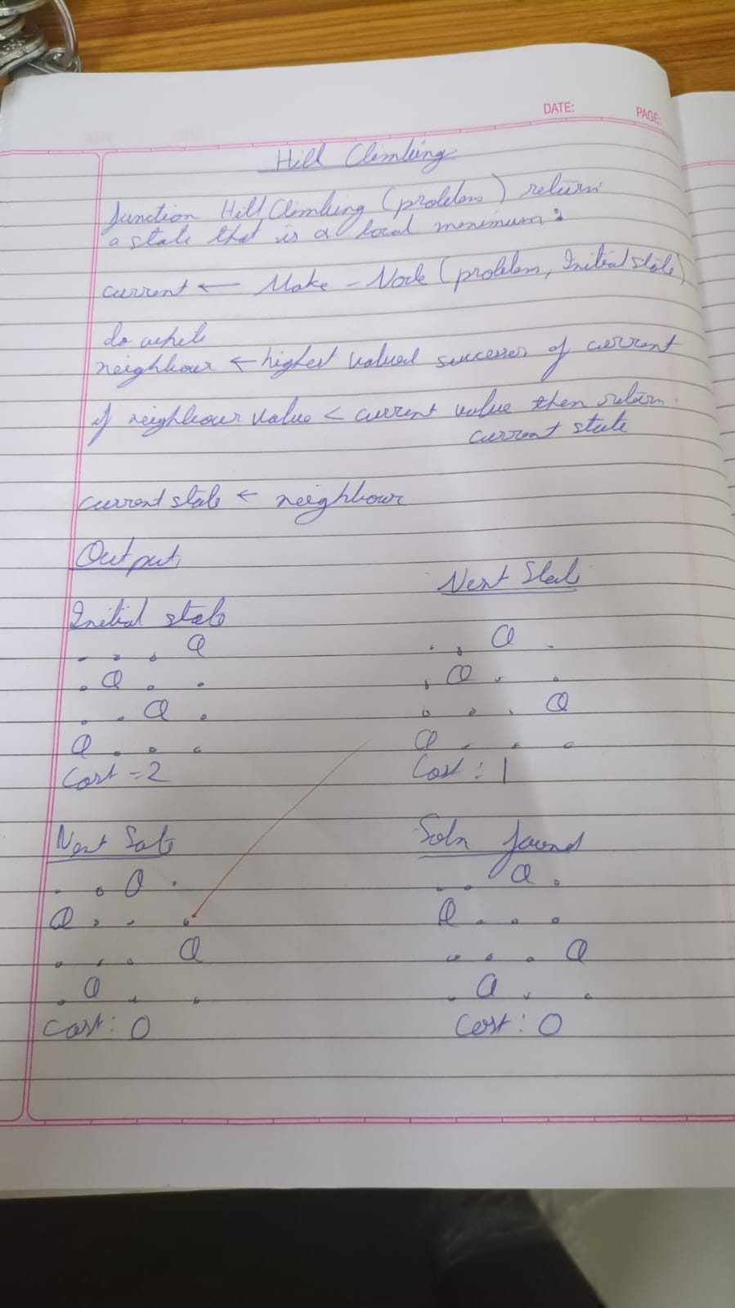

import random
import time

def print_board(state):
"""Prints the chessboard for a given state."""
n = len(state)
for row in range(n):
line = ""
for col in range(n):
if state[col] == row:
line += "Q "
else:
line += ". "
print(line)
print()

def compute_heuristic(state):
"""Computes the number of attacking pairs of queens."""
h = 0
n = len(state)
for i in range(n):
for j in range(i + 1, n):
if state[i] == state[j] or abs(state[i] - state[j]) == abs(i - j):
h += 1
return h

def get_neighbors(state):
"""Generates all possible neighbors by moving one queen in its column."""
neighbors = []
n = len(state)
for col in range(n):
for row in range(n):
if row != state[col]:
neighbor = list(state)
neighbor[col] = row
neighbors.append(neighbor)
return neighbors

def hill_climb_verbose(initial_state, step_delay=0.5):
"""Hill climbing algorithm with verbose output at each step."""
current = initial_state
current_h = compute_heuristic(current)
step = 0

print(f"Initial state (heuristic: {current_h}):")
print_board(current)
time.sleep(step_delay)

while True:
neighbors = get_neighbors(current)
next_state = None
next_h = current_h

for neighbor in neighbors:
h = compute_heuristic(neighbor)
if h < next_h:
next_state = neighbor
next_h = h

if next_h >= current_h:
print(f"Reached local minimum at step {step}, heuristic: {current_h}")
return current, current_h

current = next_state
current_h = next_h
step += 1
print(f"Step {step}: (heuristic: {current_h})")
print_board(current)
time.sleep(step_delay)

def solve_n_queens_verbose(n, max_restarts=1000):
"""Solves N-Queens problem using hill climbing with restarts and verbose output."""
for attempt in range(max_restarts):
print(f"\n=== Restart {attempt + 1} ===\n")
initial_state = [random.randint(0, n - 1) for _ in range(n)]
solution, h = hill_climb_verbose(initial_state)
if h == 0:
print(f" Solution found after {attempt + 1} restart(s):")
print_board(solution)
return solution
else:
print(f"No solution in this attempt (local minimum).\n")
print("Failed to find a solution after max restarts.")
return None

# --- Run the algorithm ---
if __name__ == "__main__":
N = int(input("Enter the number of queens (N): "))
solve_n_queens_verbose(N)

Program 5

Simulated Annealing to Solve 8-Queens problem

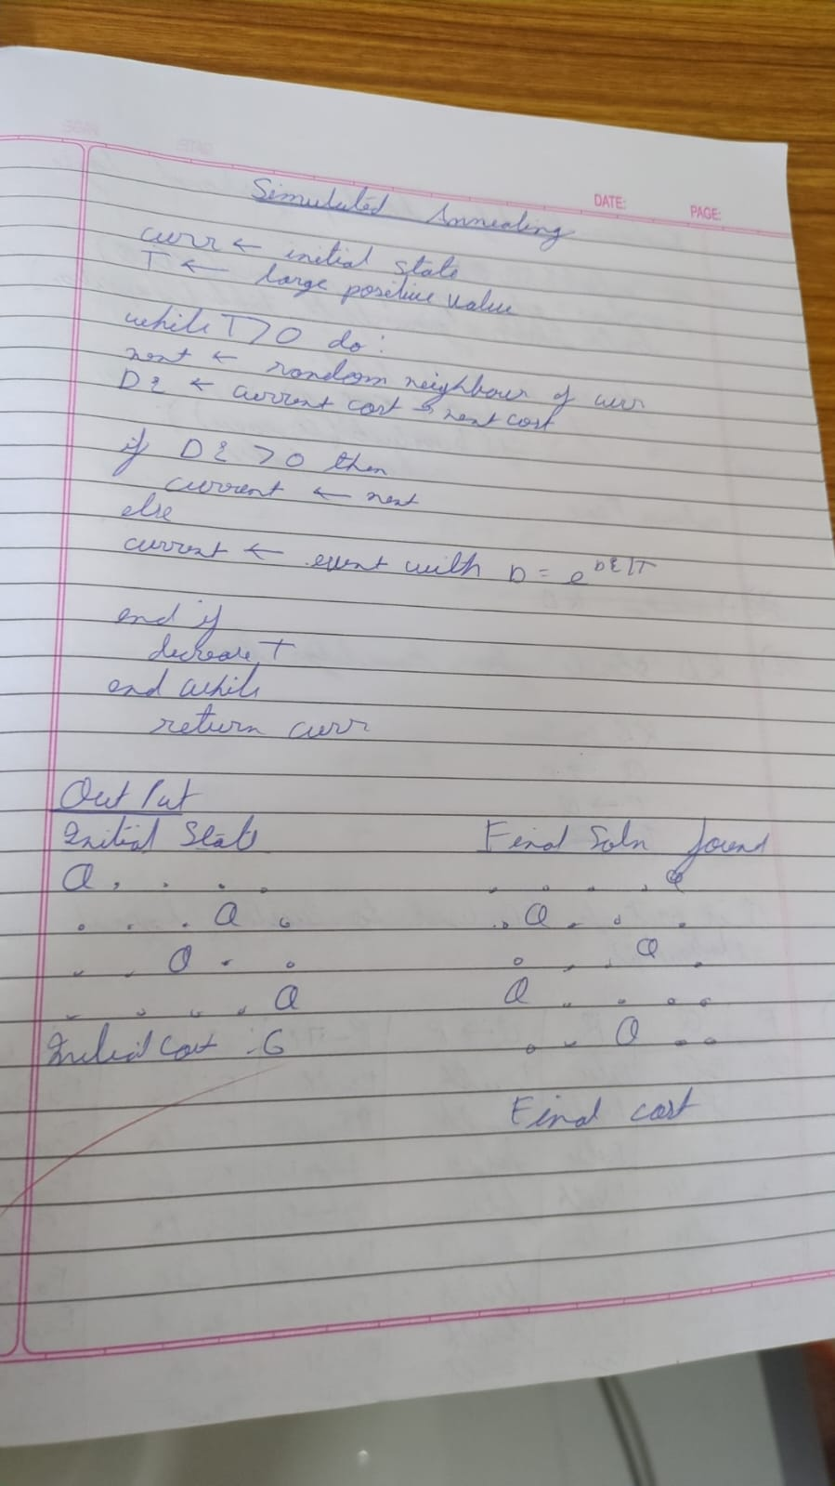

import random
import math

def compute_heuristic(state):
"""Number of attacking pairs."""
h = 0
n = len(state)
for i in range(n):
for j in range(i + 1, n):
if state[i] == state[j] or abs(state[i] - state[j]) == abs(i - j):
h += 1
return h

def random_neighbor(state):
"""Returns a neighbor by randomly changing one queen's row."""
n = len(state)
neighbor = state[:]
col = random.randint(0, n - 1)
old_row = neighbor[col]
new_row = random.choice([r for r in range(n) if r != old_row])
neighbor[col] = new_row
return neighbor

def dual_simulated_annealing(n, max_iter=10000, initial_temp=100.0, cooling_rate=0.99):
"""Simulated Annealing with dual acceptance strategy."""
current = [random.randint(0, n - 1) for _ in range(n)]
current_h = compute_heuristic(current)
temperature = initial_temp

for step in range(max_iter):
if current_h == 0:
print(f"✅ Solution found at step {step}")
return current

neighbor = random_neighbor(current)
neighbor_h = compute_heuristic(neighbor)
delta = neighbor_h - current_h

if delta < 0:
current = neighbor
current_h = neighbor_h
else:
# Dual acceptance: standard + small chance of higher uphill move
probability = math.exp(-delta / temperature)
if random.random() < probability:
current = neighbor
current_h = neighbor_h

temperature *= cooling_rate
if temperature < 1e-5: # Restart if stuck
temperature = initial_temp
current = [random.randint(0, n - 1) for _ in range(n)]
current_h = compute_heuristic(current)

print("❌ Failed to find solution within max iterations.")
return None

# --- Run the algorithm ---
if __name__ == "__main__":
N = int(input("Enter number of queens (N): "))
solution = dual_simulated_annealing(N)

if solution:
print("Position format:")
print("[", " ".join(str(x) for x in solution), "]")
print("Heuristic:", compute_heuristic(solution))

Program 6
Create a knowledge base using propositional logic and show that the given query entails the knowledge base or not:
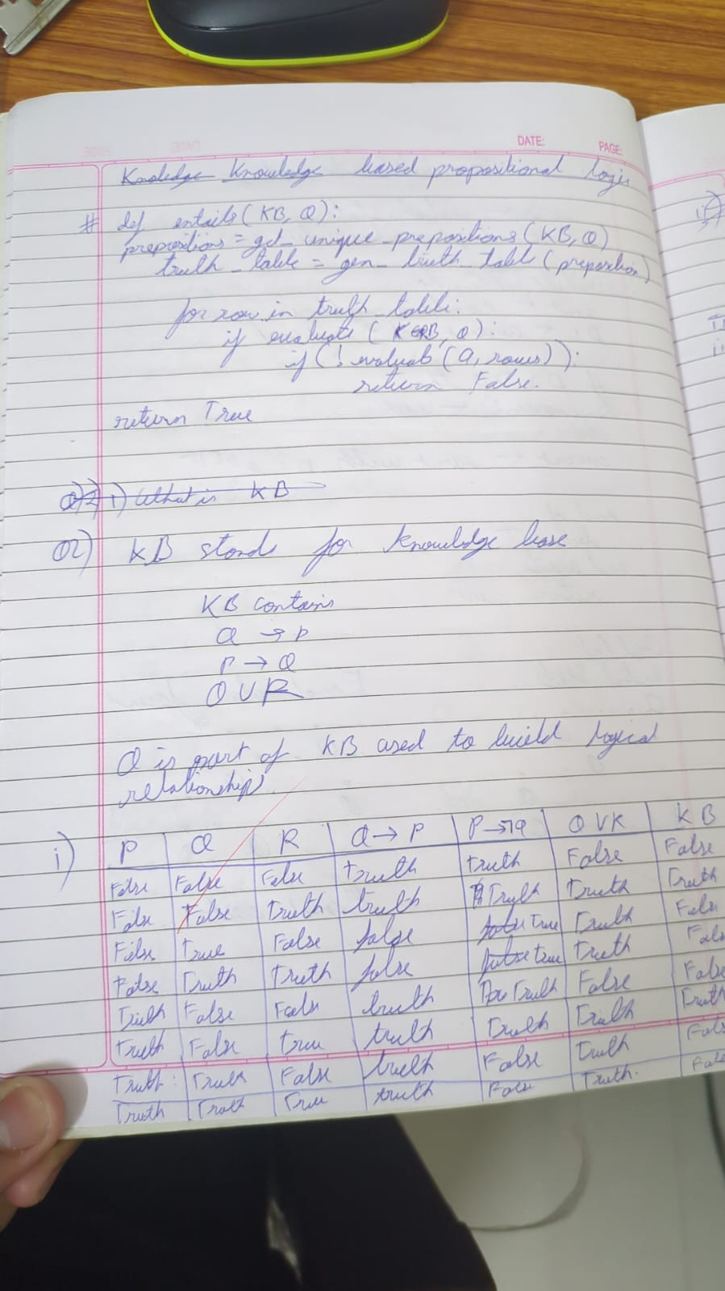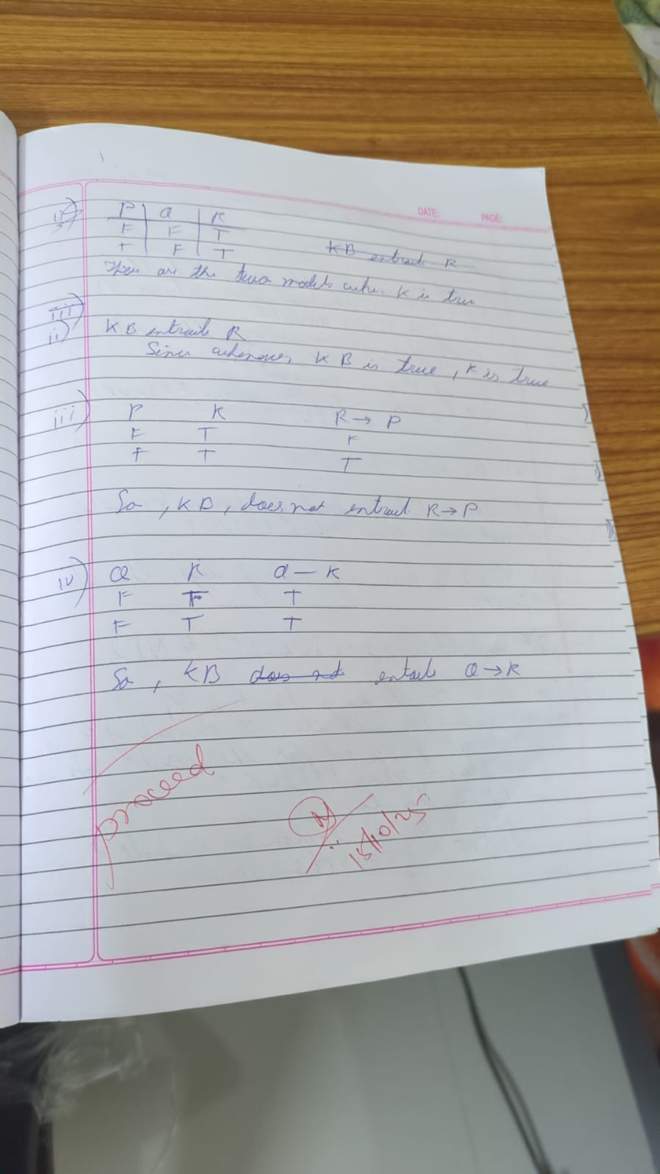

from typing import List, Tuple, Dict, Set, Union

Predicate = Tuple[str, Tuple[str, ...]]

class Rule:
def __init__(self, head: Predicate, body: List[Predicate]):
self.head = head
self.body = body

def __repr__(self):
body_str = ', '.join(f"{p[0]}{p[1]}" for p in self.body)
return f"{body_str} => {self.head[0]}{self.head[1]}"

# Knowledge base
class KnowledgeBase:
def __init__(self):
self.facts: Set[Predicate] = set()
self.rules: List[Rule] = []

def add_fact(self, fact: Predicate):
self.facts.add(fact)

def add_rule(self, rule: Rule):
self.rules.append(rule)

def forward_chain(self, query: Predicate) -> bool:
inferred = set(self.facts)
added = True

while added:
added = False
for rule in self.rules:
if all(self._match_fact(body_pred, inferred) for body_pred in rule.body):
if not self._match_fact(rule.head, inferred):
inferred.add(rule.head)
added = True
print(f"Inferred: {rule.head}")

if self._match_fact(query, inferred):
return True
return self._match_fact(query, inferred)

def _match_fact(self, pred: Predicate, fact_set: Set[Predicate]) -> bool:
return pred in fact_set

# --- Example usage ---
if __name__ == "__main__":
kb = KnowledgeBase()

kb.add_fact(("Parent", ("John", "Mary")))
kb.add_fact(("Parent", ("Mary", "Sue")))

facts_list = list(kb.facts)
for f1 in facts_list:
for f2 in facts_list:
if f1[0] == "Parent" and f2[0] == "Parent":
if f1[1][1] == f2[1][0]:
head = ("Grandparent", (f1[1][0], f2[1][1]))
body = [f1, f2]
kb.add_rule(Rule(head, body))

query = ("Grandparent", ("John", "Sue"))
result = kb.forward_chain(query)

print(f"Query {query} is", "True" if result else "False")

Program 7
Implement unification in first order logic:

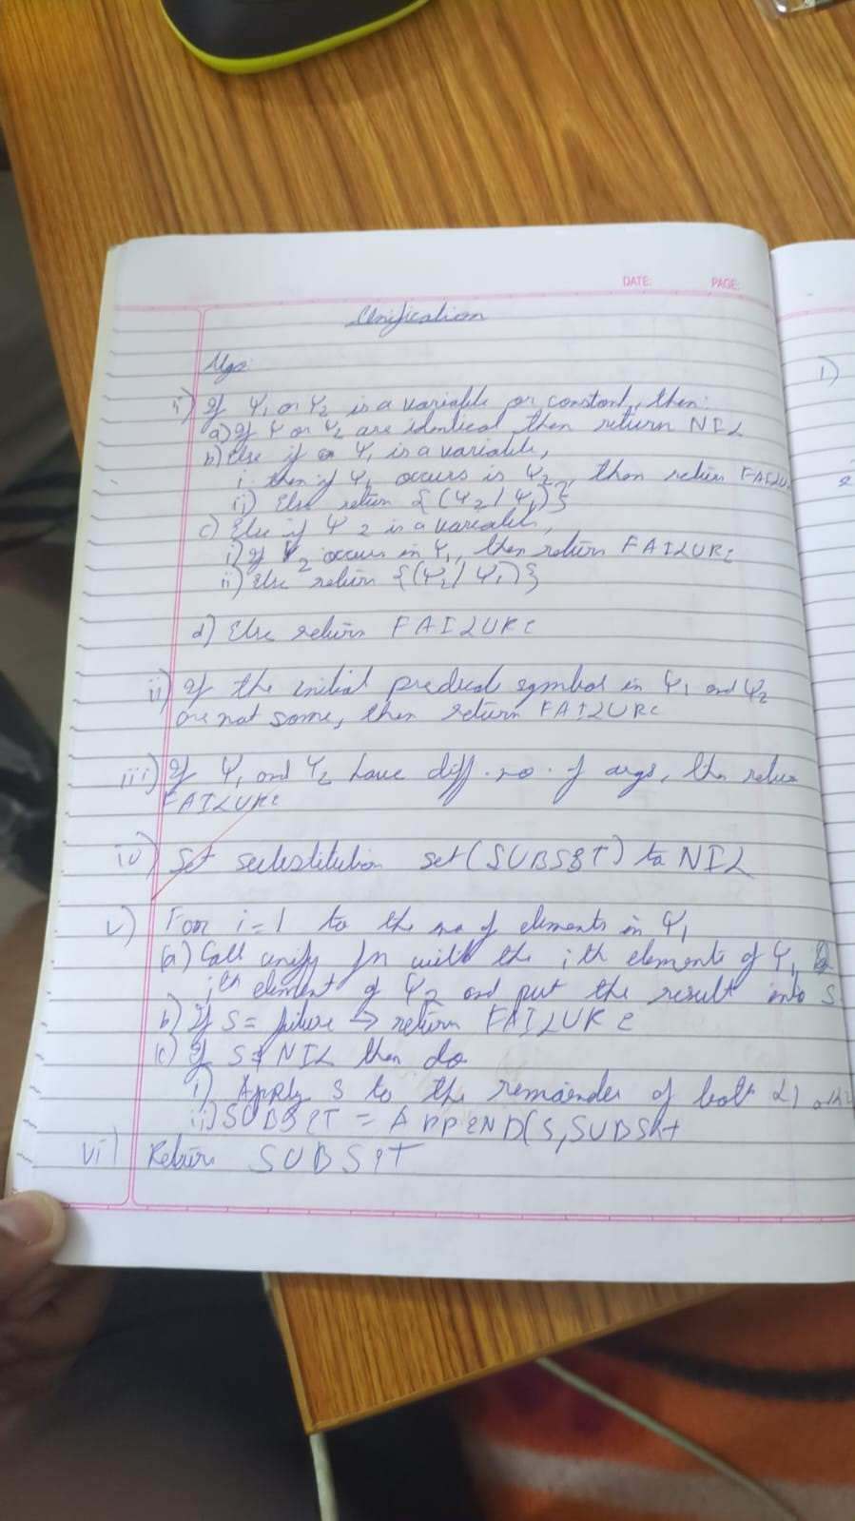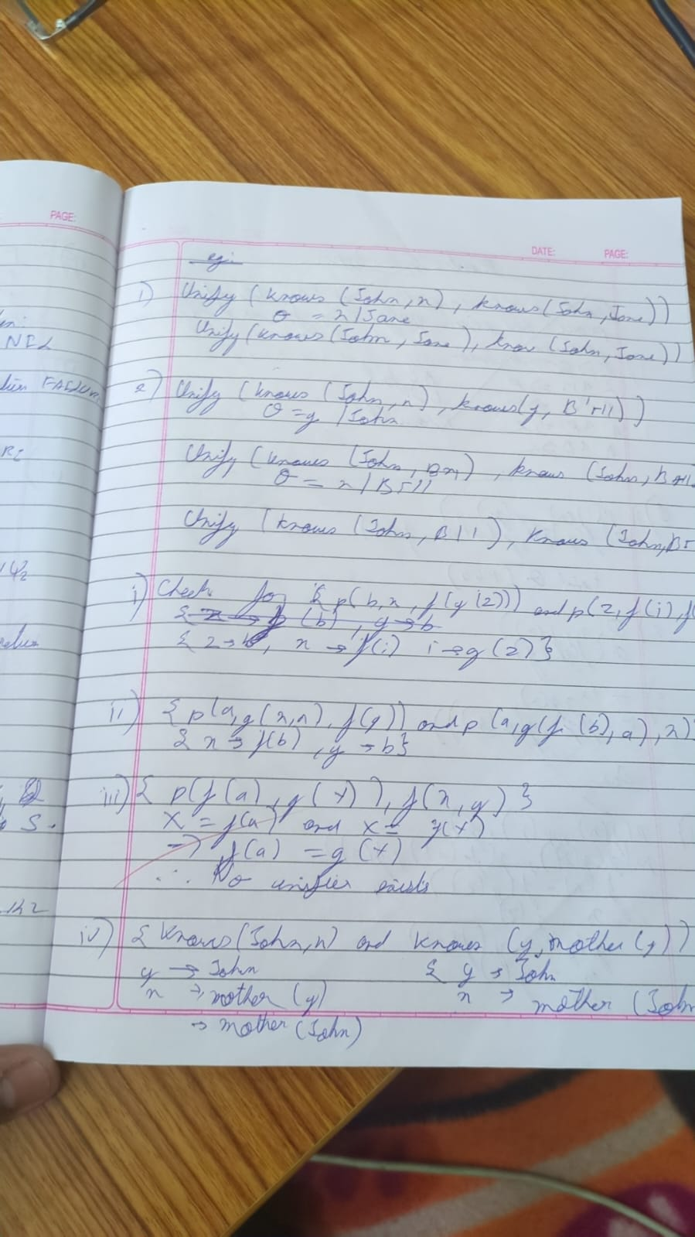

import json

# --- Helper Functions for Term Manipulation ---

def is_variable(term):
"""Checks if a term is a variable (a single capital letter string)."""
return isinstance(term, str) and len(term) == 1 and 'A' <= term[0] <= 'Z'

def occurs_check(variable, term, sigma):
"""
Checks if 'variable' occurs anywhere in 'term' under the current substitution 'sigma'.
This prevents infinite recursion (e.g., unifying X with f(X)).
"""
term = apply_substitution(term, sigma) # Check the substituted term

if term == variable:
return True

# If the term is a list (function/predicate), check its arguments recursively
if isinstance(term, list):
for arg in term[1:]:
if occurs_check(variable, arg, sigma):
return True

return False

def apply_substitution(term, sigma):
"""
Applies the current substitution 'sigma' to a 'term' recursively.
"""
if is_variable(term):
# If the variable is bound in sigma, apply the binding
if term in sigma:
# Recursively apply the rest of the substitutions to the binding's value
# This is critical for chains like X/f(Y), Y/a -> X/f(a)
return apply_substitution(sigma[term], sigma)
return term

if isinstance(term, list):
# Apply substitution to the arguments of the function/predicate
new_term = [term[0]] # Keep the function/predicate symbol
for arg in term[1:]:
new_term.append(apply_substitution(arg, sigma))
return new_term

# Term is a constant or an unhandled type, return as is
return term

def term_to_string(term):
"""
Converts the internal list representation of a term into standard logic notation string.
e.g., ['f', 'Y'] -> "f(Y)"
"""
if isinstance(term, str):
return term

if isinstance(term, list):
# Term is a function or predicate
symbol = term[0]
args = [term_to_string(arg) for arg in term[1:]]
return f"{symbol}({', '.join(args)})"

return str(term)

# --- Main Unification Function ---

def unify(term1, term2):
"""
Implements the Unification Algorithm to find the MGU for term1 and term2.
Returns the MGU as a dictionary or None if unification fails.
"""
# Initialize the substitution set (MGU)
sigma = {}

# Initialize the list of pairs to resolve (the difference set)
diff_set = [[term1, term2]]

print(f"--- Unification Process Started ---")
print(f"Initial Terms:")
print(f"L1: {term_to_string(term1)}")
print(f"L2: {term_to_string(term2)}")
print("-" * 35)

while diff_set:
# Pop the current pair of terms to unify
t1, t2 = diff_set.pop(0)

# 1. Apply the current MGU to the terms before comparison
t1_prime = apply_substitution(t1, sigma)
t2_prime = apply_substitution(t2, sigma)

print(f"Attempting to unify: {term_to_string(t1_prime)} vs {term_to_string(t2_prime)}")

# 2. Check if terms are identical
if t1_prime == t2_prime:
print(f" -> Identical. Current MGU: {term_to_string(sigma)}")
continue

# 3. Handle Variable-Term unification
if is_variable(t1_prime):
var, term = t1_prime, t2_prime
elif is_variable(t2_prime):
var, term = t2_prime, t1_prime
else:
var, term = None, None

if var:
# Check if term is a variable, and if so, don't bind V/V
if is_variable(term):
print(f" -> Both are variables. Skipping {var} / {term}")
# Ensure they are added back if not identical (which is caught by step 2).
# If V1 != V2, we add V1/V2 or V2/V1 to sigma. Since step 2 handles V/V, this means V1 != V2 here.
if var != term:
sigma[var] = term
print(f" -> Variable binding added: {var} / {term_to_string(term)}. New MGU: {term_to_string(sigma)}")
# Occurs Check: Fail if the variable occurs in the term it's being bound to
elif occurs_check(var, term, sigma):
print(f" -> OCCURS CHECK FAILURE: Variable {var} occurs in {term_to_string(term)}")
return None

# Create a new substitution {var / term}
else:
sigma[var] = term
print(f" -> Variable binding added: {var} / {term_to_string(term)}. New MGU: {term_to_string(sigma)}")

# 4. Handle Complex Term (Function/Predicate) unification
elif isinstance(t1_prime, list) and isinstance(t2_prime, list):
# Check functor/predicate symbol and arity (number of arguments)
if t1_prime[0] != t2_prime[0] or len(t1_prime) != len(t2_prime):
print(f" -> FUNCTOR/ARITY MISMATCH: {t1_prime[0]} != {t2_prime[0]} or arity mismatch.")
return None

# Add corresponding arguments to the difference set
# Start from index 1 (after the symbol)
for arg1, arg2 in zip(t1_prime[1:], t2_prime[1:]):
diff_set.append([arg1, arg2])
print(f" -> Complex terms matched. Adding arguments to difference set.")

# 5. Handle Constant-Constant or other mismatches (Fail)
else:
print(f" -> TYPE/CONSTANT MISMATCH: {term_to_string(t1_prime)} and {term_to_string(t2_prime)} cannot be unified.")
return None

print("-" * 35)
print("--- Unification Successful ---")

# Final cleanup to ensure all bindings are fully resolved
final_mgu = {k: apply_substitution(v, sigma) for k, v in sigma.items()}
return final_mgu

# --- Define the Input Terms ---

# L1 = Q(a, g(X, a), f(Y))
literal1 = ['Q', 'a', ['g', 'X', 'a'], ['f', 'Y']]

# L2 = Q(a, g(f(b), a), X)
literal2 = ['Q', 'a', ['g', ['f', 'b'], 'a'], 'X']

# --- Run the Unification ---

mgu_result = unify(literal1, literal2)

if mgu_result is not None:
print("\n[ Final MGU Result ]")

# Format the final MGU for display using the new helper function
clean_mgu = {k: term_to_string(v) for k, v in mgu_result.items()}
final_output = ', '.join([f"{k} / {v}" for k, v in clean_mgu.items()])
print(f"Final MGU: {{ {final_output} }}")

# --- Verification ---
print("\n[ Verification ]")
unified_l1 = apply_substitution(literal1, mgu_result)
unified_l2 = apply_substitution(literal2, mgu_result)

print(f"L1 after MGU: {term_to_string(unified_l1)}")
print(f"L2 after MGU: {term_to_string(unified_l2)}")

if unified_l1 == unified_l2:
print("-> SUCCESS: L1 and L2 are identical after applying the MGU.")
else:
print("-> ERROR: Unification failed verification.")
else:
print("\nUnification FAILED.")

Program 8
Create a knowledge base consisting of first order logic statements and prove the given query using forward reasoning:

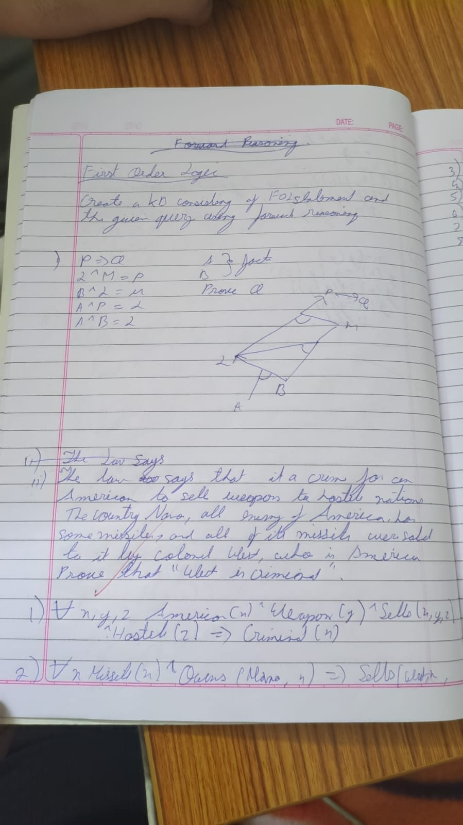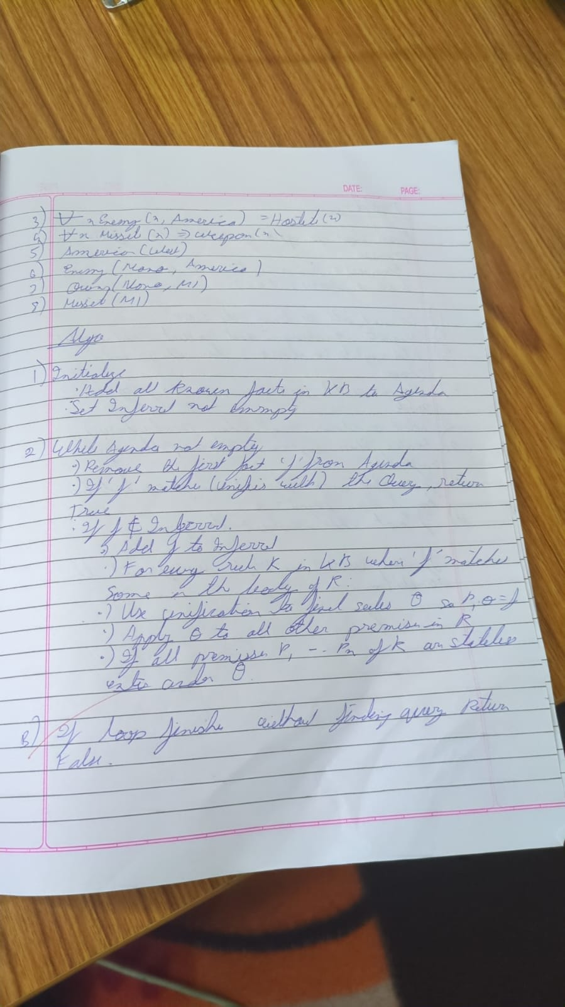
from typing import List, Tuple, Dict, Set, Union

Predicate = Tuple[str, Tuple[str, ...]]

class Rule:
def __init__(self, head: Predicate, body: List[Predicate]):
self.head = head
self.body = body

def __repr__(self):
body_str = ', '.join(f"{p[0]}{p[1]}" for p in self.body)
return f"{body_str} => {self.head[0]}{self.head[1]}"

# Knowledge base
class KnowledgeBase:
def __init__(self):
self.facts: Set[Predicate] = set()
self.rules: List[Rule] = []

def add_fact(self, fact: Predicate):
self.facts.add(fact)

def add_rule(self, rule: Rule):
self.rules.append(rule)

def forward_chain(self, query: Predicate) -> bool:
inferred = set(self.facts)
added = True

while added:
added = False
for rule in self.rules:
if all(self._match_fact(body_pred, inferred) for body_pred in rule.body):
if not self._match_fact(rule.head, inferred):
inferred.add(rule.head)
added = True
print(f"Inferred: {rule.head}")

if self._match_fact(query, inferred):
return True
return self._match_fact(query, inferred)

def _match_fact(self, pred: Predicate, fact_set: Set[Predicate]) -> bool:
return pred in fact_set

# --- Example usage ---
if __name__ == "__main__":
kb = KnowledgeBase()

kb.add_fact(("Parent", ("John", "Mary")))
kb.add_fact(("Parent", ("Mary", "Sue")))

facts_list = list(kb.facts)
for f1 in facts_list:
for f2 in facts_list:
if f1[0] == "Parent" and f2[0] == "Parent":
if f1[1][1] == f2[1][0]:
head = ("Grandparent", (f1[1][0], f2[1][1]))
body = [f1, f2]
kb.add_rule(Rule(head, body))

query = ("Grandparent", ("John", "Sue"))
result = kb.forward_chain(query)

print(f"Query {query} is", "True" if result else "False")

Program 9:
Create a knowledge base consisting of first order logic statements and prove the given query using Resolution.
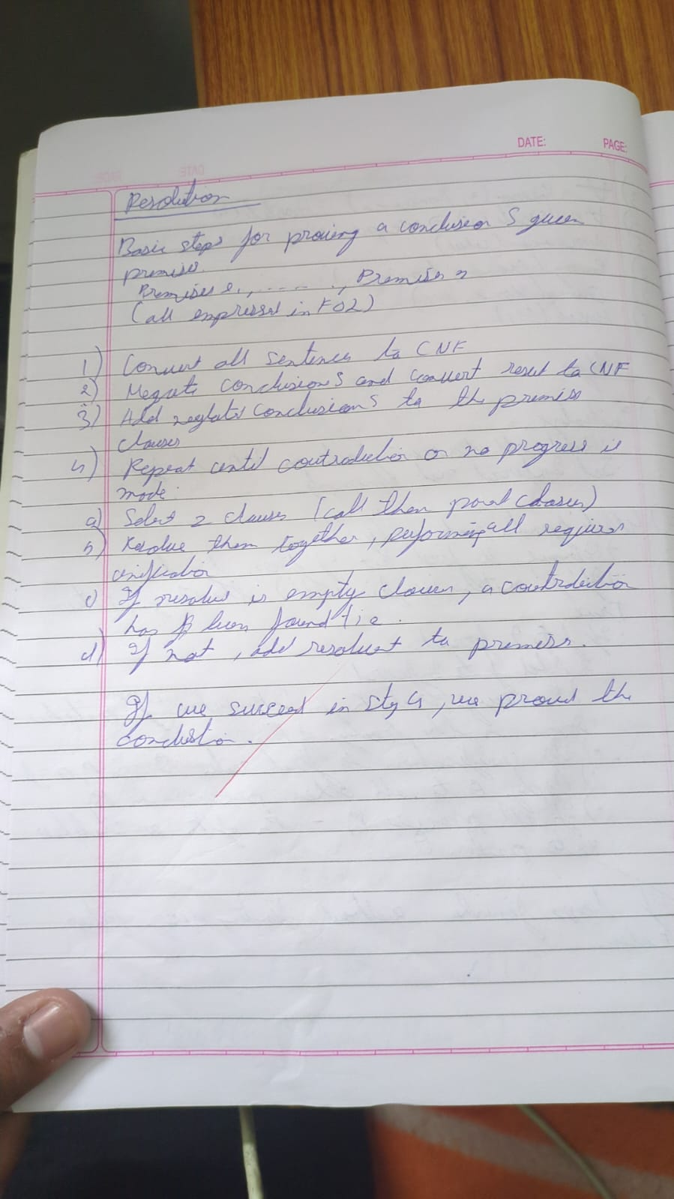
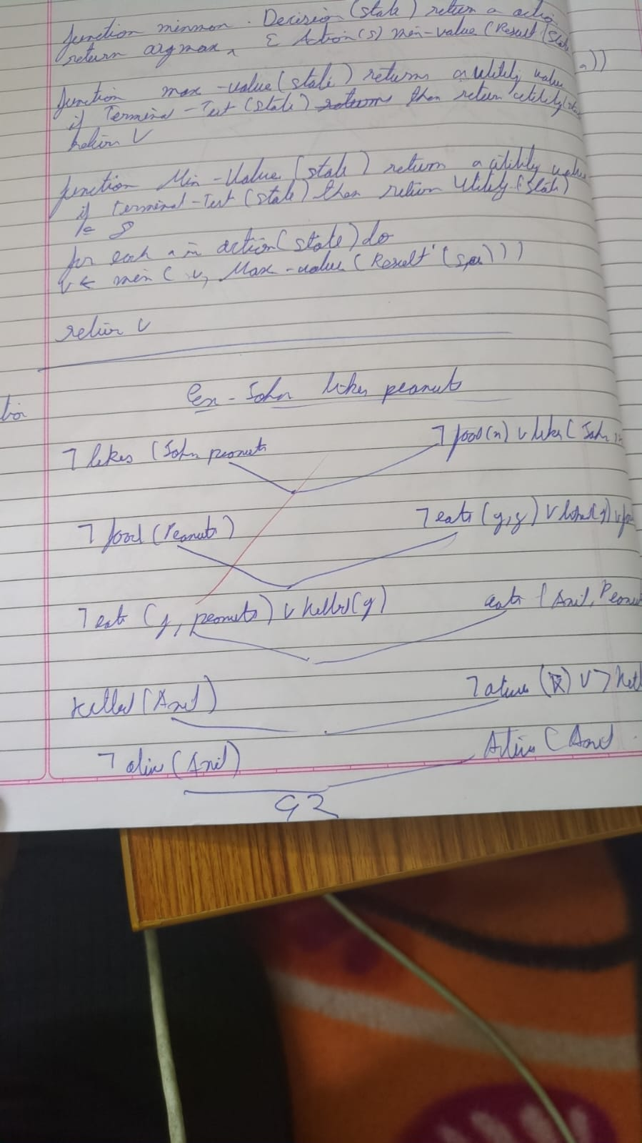

from itertools import combinations

def pl_resolution(KB, query):
# Negate the query and add to KB
clauses = KB + [negate(query)]
print("Initial Clauses:")
for c in clauses:
print(c)
print("-" * 40)

new = set()
while True:
# Generate all possible pairs of clauses
pairs = list(combinations(clauses, 2))
for (ci, cj) in pairs:
resolvents = resolve(ci, cj)
if [] in resolvents:
print(f"Derived empty clause from {ci} and {cj}")
return True
new.update(tuple(sorted(r)) for r in resolvents)

if new.issubset(set(tuple(sorted(c)) for c in clauses)):
# No new clauses added — cannot derive contradiction
return False
for c in new:
if list(c) not in clauses:
clauses.append(list(c))

def resolve(ci, cj):
"""Resolve two clauses and return the resolvents."""
resolvents = []
for di in ci:
for dj in cj:
if di == negate(dj):
new_clause = list(set(ci + cj))
new_clause.remove(di)
new_clause.remove(dj)
resolvents.append(new_clause)
return resolvents

def negate(literal):
"""Negate a literal."""
if literal.startswith('~'):
return literal[1:]
else:
return '~' + literal

KB = [
['~R', 'W'],
['~W', 'G'],
['R']
]

query = 'G'

# --- Run Resolution ---
entailed = pl_resolution(KB, query)
print("\nResult:")
if entailed:
print(f"✅ The knowledge base entails {query}.")
else:
print(f"❌ The knowledge base does NOT entail {query}.")

Program 10:
Implement Alpha-Beta Pruning

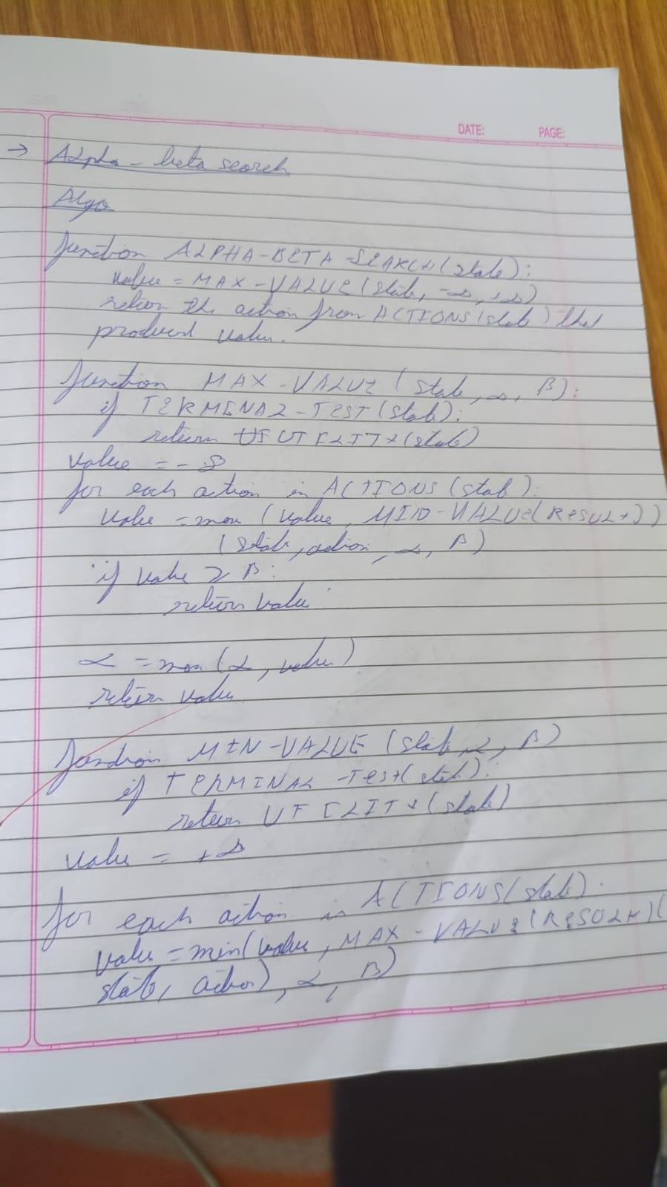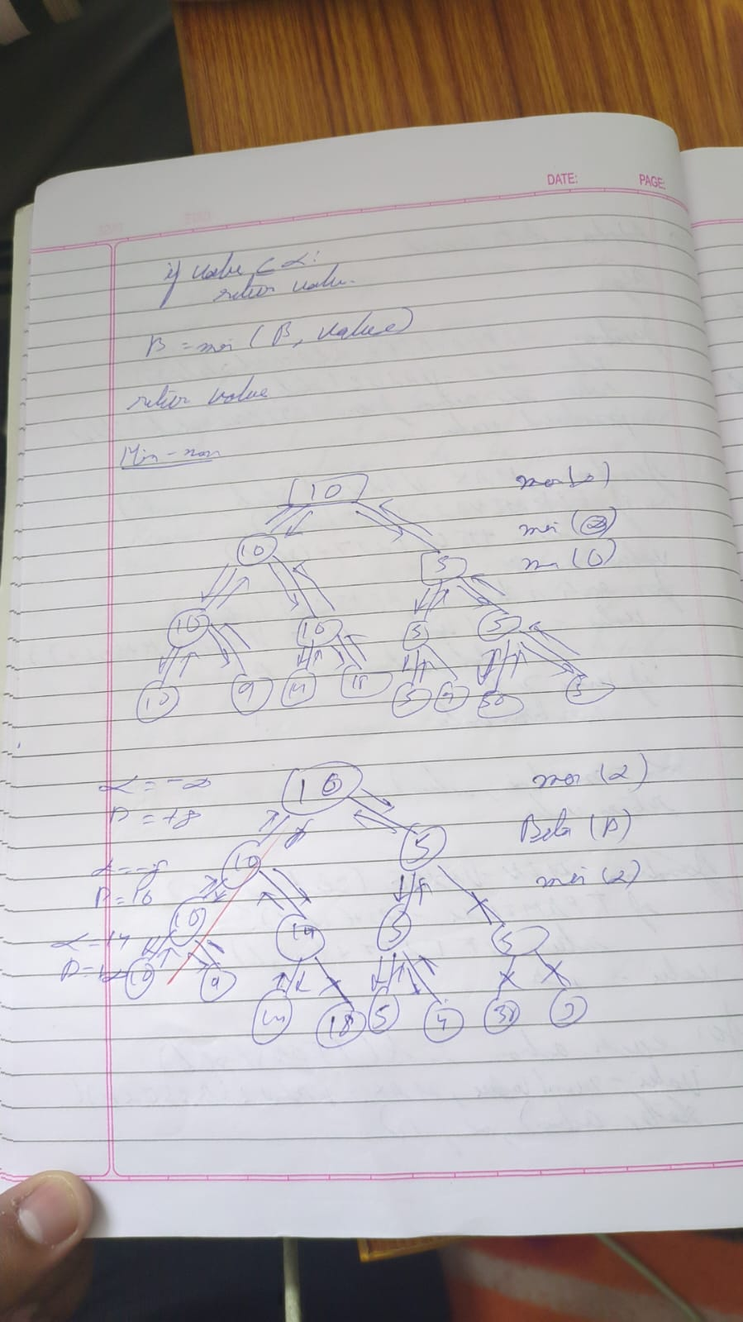
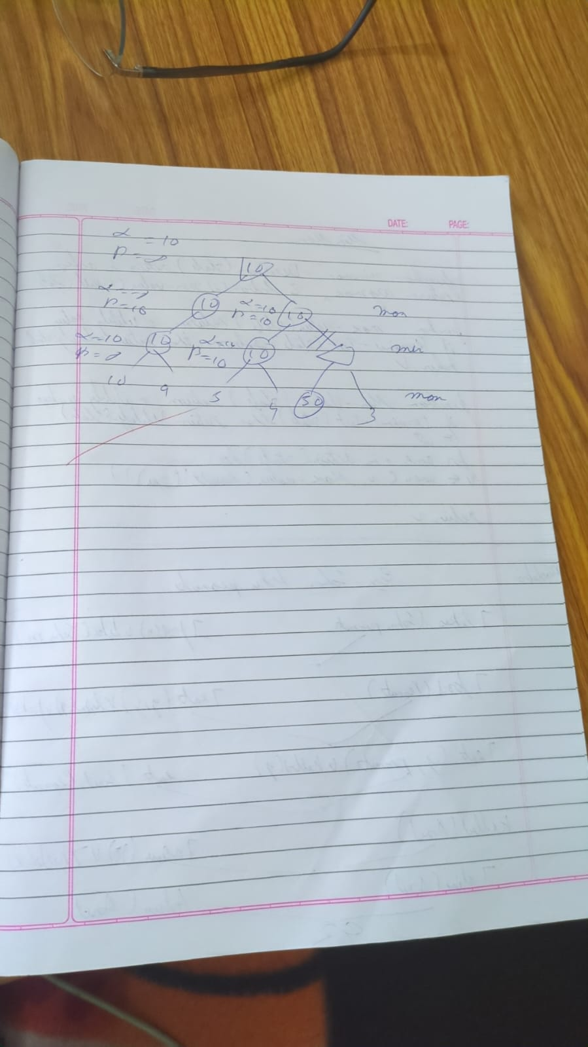

# --- Alpha-Beta Pruning Implementation ---

import math

# Minimax with Alpha-Beta Pruning
def alphabeta(depth, node_index, maximizing_player, values, alpha, beta, max_depth):
"""
depth: current depth in the game tree
node_index: index of the current node in the list of values
maximizing_player: boolean, True if it's the maximizing player's turn
values: list of terminal node values
alpha, beta: alpha-beta values for pruning
max_depth: maximum depth of the tree
"""
# Base case: if we reach the leaf node
if depth == max_depth:
return values[node_index]

if maximizing_player:
best = -math.inf
# Explore left and right child
for i in range(2):
val = alphabeta(depth + 1, node_index * 2 + i, False, values, alpha, beta, max_depth)
best = max(best, val)
alpha = max(alpha, best)
# Prune
if beta <= alpha:
break
return best
else:
best = math.inf
# Explore left and right child
for i in range(2):
val = alphabeta(depth + 1, node_index * 2 + i, True, values, alpha, beta, max_depth)
best = min(best, val)
beta = min(beta, best)
# Prune
if beta <= alpha:
break
return best

# --- Example Game Tree ---

# Terminal node values (leaf nodes)
values = [3, 5, 6, 9]

# Tree depth = log2(len(values)) = 2
max_depth = 2

# Run alpha-beta pruning
best_value = alphabeta(0, 0, True, values, -math.inf, math.inf, max_depth)
print(f"The optimal value is: {best_value}")

